Salesforce Design Document Template

Bitwise Training – Feb 2025

Contents

0. Introduction 3

1 Custom objects 4

2. Standard Objects 5

3. Record Types: 6

4. Page Layouts 6

5. Triggers 7

6. Flows 7

7. Reports and Dashboards 8

8. Schematic of the journey builder 9

# 0. Introduction

Process to LIC Education fund subscription

1. Created one parent campaign LIC
2. Next, created two child campaigns LIC Education Fund & LIC SIP Plan
3. Leads are collected by ways-Web to form
4. Adding those Lead to a particular campaign of if select both then adding into both campaign by flows (LeadtoContactbyAddingCampaign).
5. If Leads subscribe then specific successful subscription mail will be sent by flow (LeadtoContactbyAddingCampaign).
6. Now Covert those Lead to Contact by Apex class and trigger   
   apex class name: (LeadConvertHandler.apxc) apex trigger name: (LeadConvertTrigger.apxt)
7. Creating a custom object college, Here we can specify only tie up college so at the time of creating admission record we can choose only tie up college.
8. Creating custom object College_Admissions adding with Lookup fields Contact and college, so whenever any student will take admission new details mail will be sent to LIC about new admission by flows(New_Admission_Notification_Flow).
9. Creating a custom object Fees_Payments and if we add any record for a student with status requested then one mail will be sent to LIC for requesting to pay the fees by flows(Requesting for Fees payment).
10. Now the status will be changed from requested to Pending and if College receives a successful fees payment mail from LIC then status will change to Payment Successful.
11. Now LIC and College both will send a mail to Contact that the payment process is done.

# 1 Custom objects

Object name: College_Admissions

Fields

| No | Field Name | DataType (if FK then mention object name in bracket) | Purpose/description/Remark |
| --- | --- | --- | --- |
| 1 | College Name | Lookup(College) | Name of college |
| 2 | Admission Date | Date | Date of admission |
| 3 | Contact | Lookup(Contact) | Student name |
| 4 | Course Name | Text | Name of course |
| 5 | Status | Picklist | Admitted or pending |
| 6 | Student Email | Formula |  |

Object name: College

Fields:

| No | Field Name | DataType (if FK then mention object name in bracket) | Purpose/description/Remark |
| --- | --- | --- | --- |
| 1 | College Name | Text | Name of college |
| 2 | Email | Email | college Email |

Object name: Fees_Patments

Fields:

| No | Field Name | DataType (if FK then mention object name in bracket) | Purpose/description/Remark |
| --- | --- | --- | --- |
| 1 | College Name | Lookup(College) | Name of college |
| 2 | Contact | Lookup(Contact) | Name of student |
| 3 | Status | Picklist | Status |
| 4 | Branch | Picklist | Course |
| 5 | amount | Picklist | Amount to be paid |
| 6 | Payment date | Date | Date of the payment |

# 2. Standard Objects

Object name: Lead

Fields

| No | Field Name | DataType (if FK then mention object name in bracket) | Purpose/description/Remark |
| --- | --- | --- | --- |
| 1 | LIC Education Fund | Checkbox | True if the lead has subscribed |
| 2 | LIC SIP Plan | Checkbox | True if the lead has subscribed |
| 3 | Subscribed Email Sent | Checkbox | True if successful email sent |

Object name: Contact

Fields

| No | Field Name | DataType (if FK then mention object name in bracket) | Purpose/description/Remark |
| --- | --- | --- | --- |
| 1 | Enrollment_Status | Checkbox | True if the contact has been enrolled |

Object name: Campaign

Fields

| No | Field Name | DataType (if FK then mention object name in bracket) | Purpose/description/Remark |
| --- | --- | --- | --- |
| 1 | Parent Campaign | Campaign | Name of Parent campaign |
| 2 | Type | Picklist | Type of Campaign |
| 3 | Status | Picklist | Campaign Status |

Schema

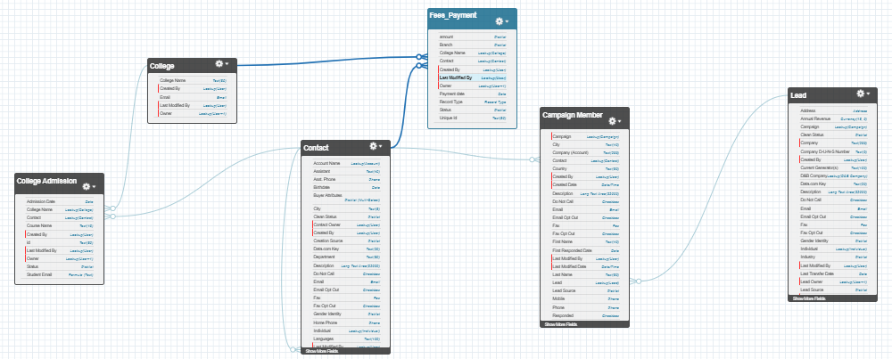



# 3. Record Types:

| No | Object | Record Type Name | Purpose |
| --- | --- | --- | --- |
| 1 | Fees_Payments | CSE | If we choose CSE in Branch the default semester fees will be shown in amount |
| 2 | Fees_Payments | IT | same for IT |
| 3 | Fees_Payments | ECE | same for ECE |

# 4. Page Layouts

| No | Object | Layout name | Purpose |
| --- | --- | --- | --- |
|  |  |  |  |
|  |  |  |  |

# 5. Triggers

| No | Object | Trigger Name | Events (before insert etc) | Purpose |
| --- | --- | --- | --- | --- |
| 1 | Lead | LeadConvertTrigger.apxt | after insert and after update | Change Lead to contact |
| 2 | Lead | LeadconvertHandler.apxc |  | this apex class which is used by apex trigger |

# 6. Flows

| No | Object | Flow Name | Entry Criteria | Action (update field etc) | Description |
| --- | --- | --- | --- | --- | --- |
| 1 | Lead | LeadtoContactbyAddingCampaign |  | Decision  Create Records  Email alert  Update  Records | Add Lead to specific Campaign, sent mail, update status |
| 2 | College_Admissions | New_Admission_Notification_Flow | if Admission Status is Admitted | sent Email Alerts | Whenever any student will take admission new details mail will be sent to LIC |
| 3 | Fees_Payments | Requesting for Fees payment | if Status is requested | sent Email  Update Record | Sent mail to LIC for requesting to pay the fees |

# 7. Reports and Dashboards

# 

# 8. Marketing cloud - SFMC

**THE END**